Problem no 01: printing 1 to N.
#include <stdio.h>
int main ()
{
int i,n;
printf("Inter the number:");
scanf("%d",&n);
for (i=1;i<n;i++){
printf("%d\n",i);
}
return 0;
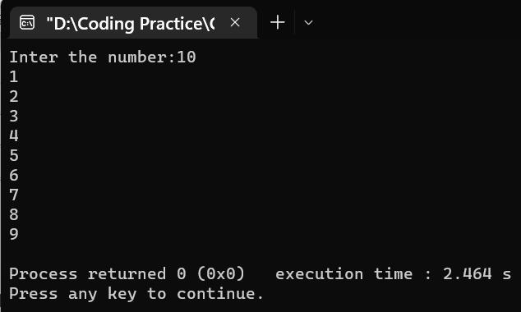

Problem no 02: Summation of all even or odd number from 1 to n.
#include <stdio.h>
int main ()
{
int i, n, oddsum=0, evensum=0;
printf("Inter the number:");
scanf("%d",&n);
for (i=1;i<=n;i++)
{
if (i%2==0)
evensum=evensum +i;
else
oddsum=oddsum +i;
}
printf("Even sum =%d\n",evensum);
printf("Odd sum =%d",oddsum);
return 0;
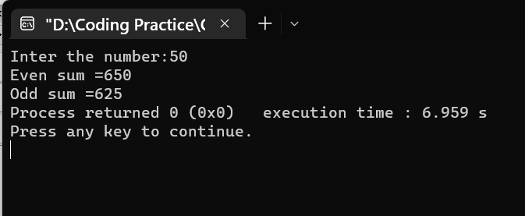
}

Problem no 03:Multiplication table.
#include<stdio.h>
int main ()
{
int i,n;
printf("Inter a number:");
scanf("%d",&n);
for (i=1;i<=10;i++){
printf("%d*%d=%d\n",n,i,n*i);

}
return 0;
}

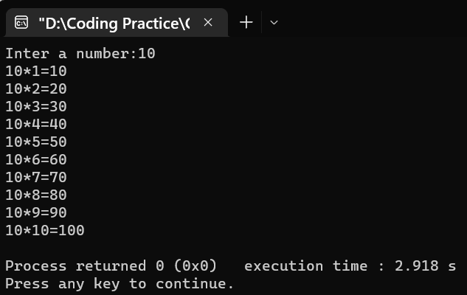

Problem no 04:Printing all alphabets from A to Z.

#include <stdio.h>
int main()
{
char ch;
printf("Alphabets from a - z are: \n");
for(ch='a'; ch<='z'; ch++)
{
printf("%c", ch);
}
return 0;
}
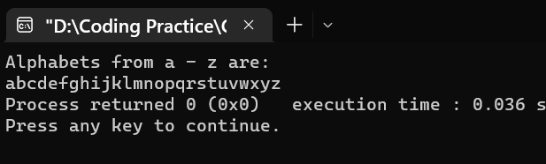
Problem no 05: printing all even or odd number from 1 to n.
#include <stdio.h>
int main () {
int i,n;
printf("Inter the number= ");
scanf("%d",&n);
for (i=1;i<=n;i++)
{
if (i%2==0) {
printf(" Is odd\n");
}
else {
printf(" Is even\n"); }
printf(" %d",i);
}
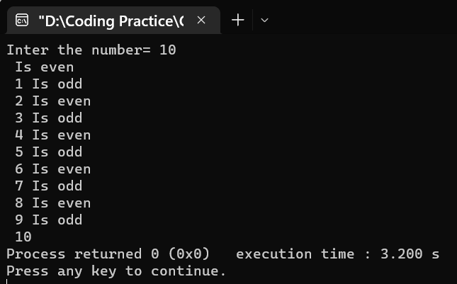
return 0;
}

Problem no 06: A program to count number of digits in a number.

#include <stdio.h>
int main ()
{
int num,count=0;
printf("Inter any number :");
scanf("%d",&num);
for (num;num;count++)
{
num=num/10;
}
printf("%d",count);
return 0;

}
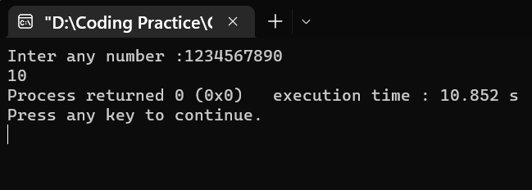

Problem no 07:print 1st and last digits in a number.

#include <stdio.h>
int main ()
{
int i, n,firstdigit,lastdigit;
printf("Inter the number :");
scanf("%d",&n);
lastdigit = n % 10;
for (i;n>0;i++)
{
firstdigit =n%10;
n=n/10;
}
printf("first digit= %d\n",firstdigit);
printf("last digit= %d",lastdigit);
return 0;
}
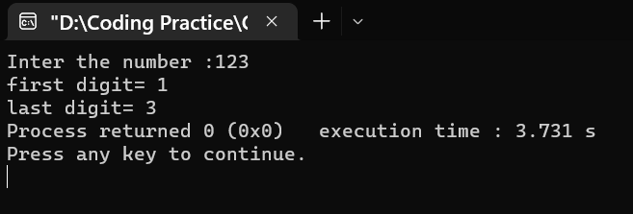
Problem no 08:printing 1st and last digits,1st digit and last digits swapping, sum of 1st and last digits.
#include<stdio.h>
int main()
{
int i, n,firstdigit,lastdigit,temp,sum,firstdigitq,lastdigitq;
printf("Inter the number :");
scanf("%d",&n);
lastdigit = n % 10;
for (i;n>0;i++)
{
firstdigit =n%10;
n=n/10;
}
{
printf("first digit= %d\n",firstdigit);
printf("last digit= %d\n\n",lastdigit);
firstdigitq=firstdigit;
lastdigitq=lastdigit;}

{temp=firstdigit;
firstdigit=lastdigit;
lastdigit=temp;

printf("After swapping :\n\n");
printf("first digit=%d\n",firstdigit);
printf("last digit=%d\n\n",lastdigit);
}
if ((firstdigitq==firstdigit)&&(lastdigitq==lastdigit))
{
printf("Number is palindrome\n\n");
}
else {
printf("Not palindrome\n\n");
}
sum=firstdigit+lastdigit;
printf("First digit + Last digit=%d\n",sum);
return 0;
}
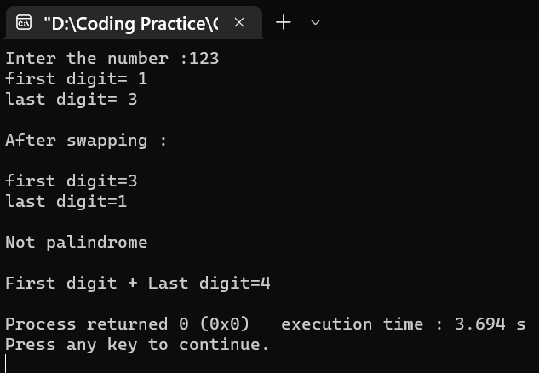
Problem no 09:Checking palindrome or not.
#include<stdio.h>
int main () {
int i,n,revers,original,remainder=0;
printf("Inter the number : ");
scanf("%d",&n);
original=n;
for(;n!=0; ){
remainder=n%10;
revers=revers*10+remainder;
n/=10;
}
if(revers==original){
printf("Number is palindrome\n "); }
else {
printf("Number is not palindrome \n"); }
return 0;
}
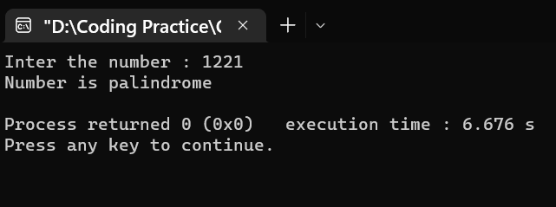

Problem no 10: sum of digits.
#include<stdio.h>
int main ()
{
int n,sum=0,revers;
printf("Inter any number : ");
scanf("%d",&n);
for (;n>0;)
{
revers=n%10;
sum=sum+revers;
n=n/10;
}
printf("sum is =%d\n",sum);
return 0;
}
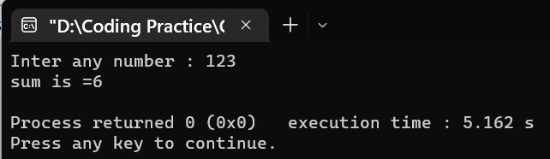

Bangladesh University of Business & Technology



Lab Report: 05
Course Title: Structured Programming Language Lab
Code: CSE-112

Submitted By | Submitted To
Name: Rakibul islam asif  ID:22235103319  Intake:51, Section:8  Department of CSE | Name: Md. Saddam Hossain.  Assistant Professor  Department of CSE BUBT

Submission Date: 09-02-2023

